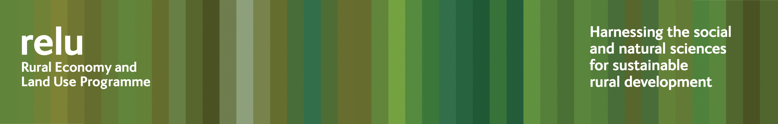

5 March 2009

Press Release

WHAT’S FAIR ABOUT THE COUNTRYSIDE?

Rural parts of Redcar and Cleveland could be the worst place to live in the English countryside, in environmental terms, according to researchers at the University of York. But it depends on exactly where you are, because Redcar and Cleveland also comes out as the most environmentally unequal, with some groups enjoying much more desirable surroundings than others.

In a project funded by the UK Research Councils’ Rural Economy and Land Use Programme, the researchers have devised four indicators that measure how desirable different local authority areas are to live in, and also how equally desirable facilities may be accessed by different groups.

Their four indicators are:

- ‘Disadvantage’ which incorporates income deprivation together with disadvantage in education and employment, poor mental well-being, fuel poverty and factors that make it difficult for people to find accommodation, such as house prices.
- ‘Inaccessibility’ which is an indicator of areas further away from schools and leisure activities, but where the up-take of countryside stewardship schemes means that farming may be more sensitive to the environment, and rivers cleaner.
- ‘Eco-desirability’ which indicates areas that have a high diversity in vegetation and wildlife, and where house prices and business activity tend to be high
- ‘Pollution’ which indicates problems such as concentrations of particulates and nitrogen dioxide, but also some social issues, for example crime rates.

Lincolnshire is ranked top on inaccessibility and also comes second on inequality within that measure. This suggests that although there are people who are isolated and unable to access basic amenities, there is a sharp social division, with other groups comparatively unaffected by such difficulties.

It sounds unfair, but the project team also wanted to know what local people themselves feel about these differences. Do they think such differences are unjust? Or is it something they take for granted, or perhaps they think there are other compensations?

Dr Meg Huby, of the University’s Department of Social Policy and Social Work, who is leading the research explained: “We wanted to move beyond the simple descriptions of inequalities and to develop an understanding of people’s perceptions of what is unfair.

“In the discussions that we have held in different areas, a common theme has been the difficulty of accessing services, and the subsequent isolation of some residents.

“Participants have tended to see this as particularly problematic and unfair for the young and the elderly. Another key concern is the shortage of affordable housing, seen to be especially unfair for young people who can’t afford to stay in the countryside, and may have to move far away from their families after leaving home.”

During the Festival of Social Science 2009 the team will particularly focus on North Yorkshire, with discussions between local policy makers, community representatives and academics.

Dr Huby said: “We want to assess the extent to which outcomes of work with local residents in other counties find resonance with practitioners in North Yorkshire.”

Notes for editors:

1 A seminar investigating the extent and nature of these inequalities is being held as part of the Economic and Social Research Council's (ESRC) Festival of Social Science on the 11th March at the County Council offices, Racecourse Lane, Northallerton. Members of the press are welcome to attend. Contact Steve Cinderby on 01904 432994 or sc9@york.ac.uk for details.

- The ESRC Festival of Social Science runs from Friday 6 March until Sunday 15 March 2009 as part of National Science and Engineering Week. The Festival provides a fascinating insight into some of the country's leading social science research and how it influences our social, economic and political lives - both now and in the future. It is organised by the Economic and Social Research Council www.esrc.ac.uk.
- The Rural Economy and Land Use Programme is a multi-disciplinary collaboration between the Economic and Social Research Council (ESRC), the Biotechnology and Biological Sciences Research Council (BBSRC) and the Natural Environment Research Council (NERC), with additional funding provided by the Scottish Government and the Department for Environment, Food and Rural Affairs. See www.relu.ac.uk for more information about the Relu programme.
- For further information contact Dr Meg Huby, tel 01904 321244, email meh1@york.ac.uk, or Relu Science Communications Manager Anne Liddon, tel 0191 2226880, email anne.liddon@ncl.ac.uk. And see the project website http://www.sei.se/relu/seira/

Ends

